In order to achieve the assessment criteria (P1) you must answer the following task:
Task 1
- Convert the following binary numbers to decimal and Hexadecimal:
- 10101010
- 11000011
- Solve the following problems :
- (00110111)₂ $+$ (01110111)₂
- (151)₁₀ $-$ (01111111)₂
(P1)
In order to achieve the assessment criteria (P2) you must answer the following task:
Task 2
- For the following diagram show in fig (1):
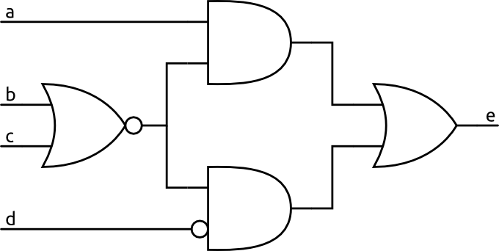
Fig (1)
- Derive the truth table.
- Find the Boolean function (Total output).
(P2)

In order to achieve the assessment criteria (P3, M1.2) you must answer the following task:
Task 3
- Proof the following Boolean rules
- A + A\B = A + B
- (A+B)(A+C) = A+BC.

- Simplify the following Boolean function using the Karnaugh mapping :
- F( A , B , C ) = ∑ ( 1, 4 , 5 , 7 )
- F( A , B , C , D ) = ∑ (1, 3 ,5, 12 , 14 , 15 )
(P3)
In order to achieve the assessment criteria (P4) you must answer the following task:
Task 4
For the following circuits choose two circuits one of them combinational circuit and the other one is sequential and then compare between combinational and sequential circuits:
- Counter.
- Encoder.
- Multiplexer.
- Shift Register.
- Full adder.
(P4)
In order to achieve the assessment criteria (P5) you must answer the following tasks:
Task 5
Describe all combinational circuits in (task 4).
(P5)

